Week 3 - Landing, Login, and Enrollment Pages Development

Alex Nieves  
CST499: Capstone for Computer Software Technology  
Instructor: Amr Elchouemi  
10/17/2022

For this week, I began on my course enrollment system project for this class. This project reminded me of a few other classes that I've taken, and I was excited to bring the experience and skills that I have obtained throughout this degree to the table and really test what I had learned over that last two years. This assignment began my installing XAMPP. Although I have gone through this process before, I needed to do it again because I recently purchased a new computer. After installation, I began work on the landing, registration, and login pages.

You must launch XAMPP after it has been downloaded and set up on your computer, go to the "Volumes" tab, and choose the "Mount" option. This will enable your file browser to display files from your server. Then, in your file browser, choose the server and go to the 'htdocs' folder. Under this folder, you can create any directories you need to test PHP files. The ".php" file extension is required; make sure your PHP files are stored as such (Williams). You can open any web browser and input the IP address found in the XAMPP application under the 'General' tab, followed by the file path of your PHP file, once you have your PHP file produced and saved (I used a program called Vision Studio Code to make mine). I used the following file location as an example: "http://192.168.64.2/CST499/home.php".

I then added my "register.php" page to the registration page I had already made. I started by constructing a form into which I could enter all the data needed for this assignment. Input lines for email, password, first and last names, addresses, phone numbers, and degrees were later added. After finishing the form, I made sure to include an action that would connect it to the newly built "connect.php" page. I connected to the phpMyAdmin database I had previously setup using this new page. I established a table in MySQL and connected to it on the connect page to ensure that all the variables entered on the registration page would be entered into the database. It turned out to be fairly difficult, but once I got it to work, it was really rewarding.

Finally, I added a new file with the name "login.php". I started by constructing a form into which I could enter all the data needed for this assignment. I then added input fields for the password and email. I linked to the 'connect.php' page I had earlier built after finishing the form. I connected to the phpMyAdmin database I made for this project using this link. I established a table in MySQL and connected to it on the connect page to ensure that all the variables entered on the registration page would be entered into the database.

In conclusion, even though I had completed most of these steps before for previous assignments and classes I still found this assignment to be quite the challenge. From installing XAMPP on mac and connecting to PHPMyAdmin, to getting my databases connected to my enrollment service, every step challenged me to remember what I have learned in these last two year of going through this degree.

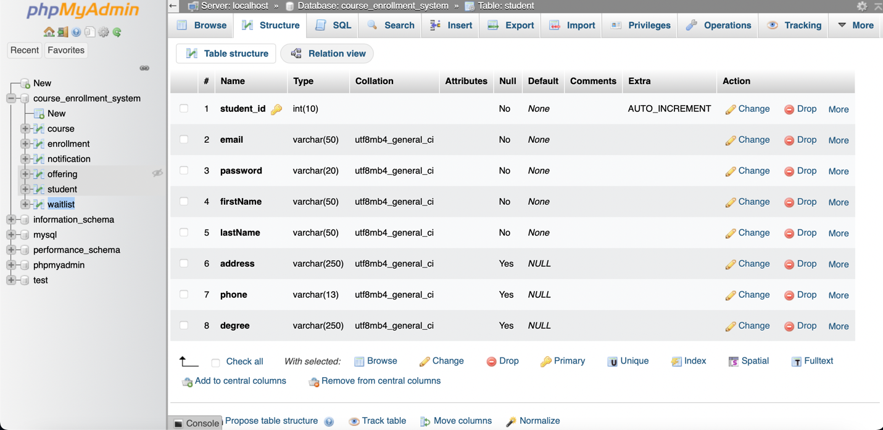

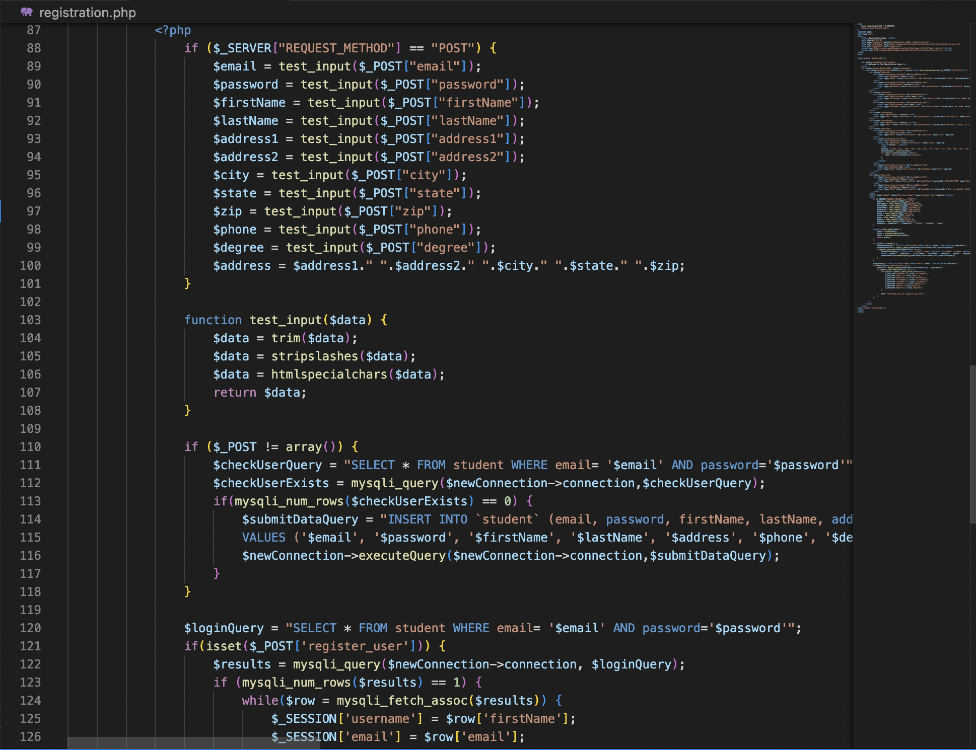

References:

Mikoluk, K. (2013, September 18). XAMPP tutorial: How to use XAMPP to run your own web serverLinks to an external site.. Udemy. <https://blog.udemy.com/xampp-tutorial>

SiteGround. (n.d.). phpMyAdmin create and populate tables tutorial.Links to an external site. https://www.siteground.com/tutorials/phpmyadmin/create-populate-tables/

Williams, S. (n.d.). How to run a PHP file in xampp. Techwalla. Retrieved May 16, 2022, from https://www.techwalla.com/articles/how-to-run-a-php-file-in-xampp